How to install Terraform on Windows

Go to the below link to download and install Terraform

https://developer.hashicorp.com/terraform/tutorials/aws-get-started/install-cli

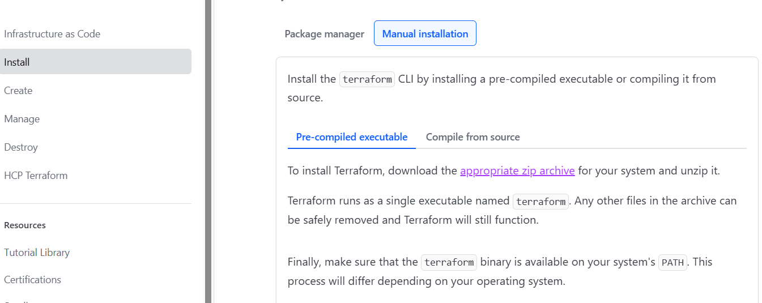

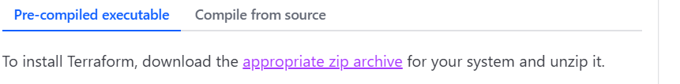

Click on the appropriate zip archive

You can select any operating system as per your requirement.

Click on AMD64 to download the zip file.

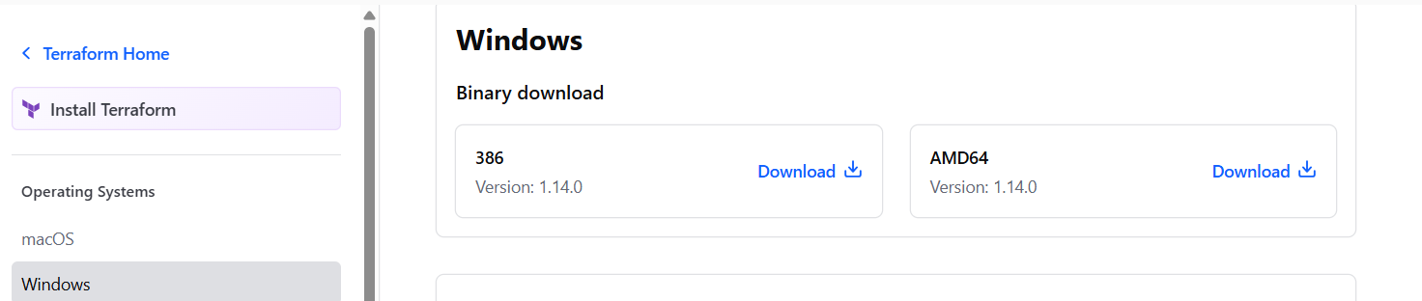

Unzip the file and extract all files as per below image..give path C:\Terraform

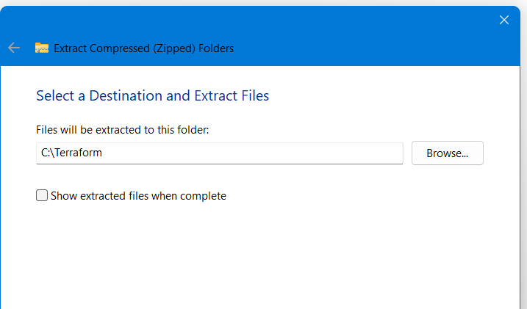

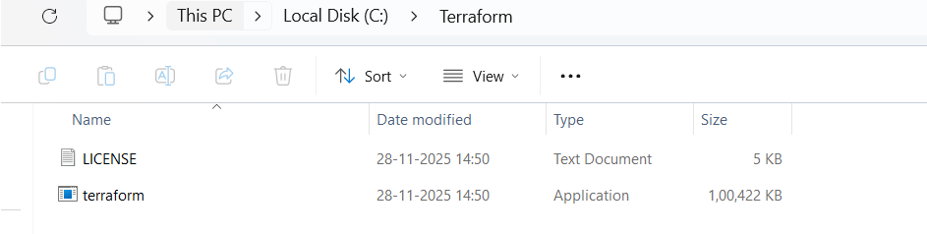

Add path C:\Terraform to the Environment variables

In the Advances tab..
Click on Environment Variables

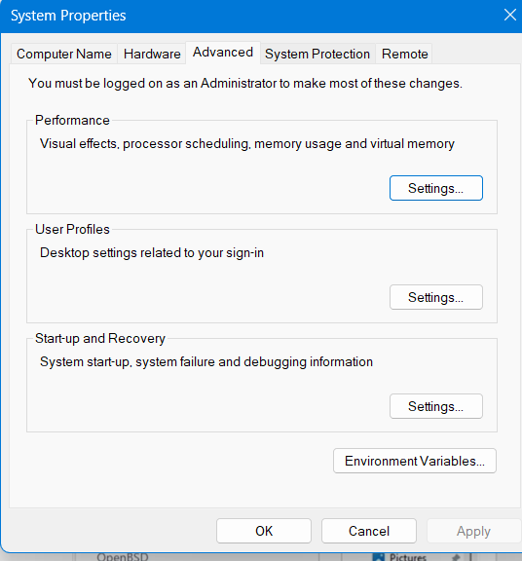

Click on Path

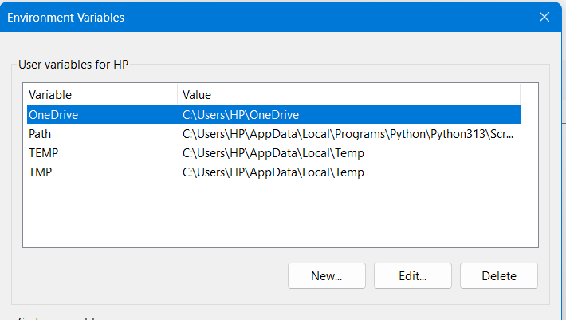

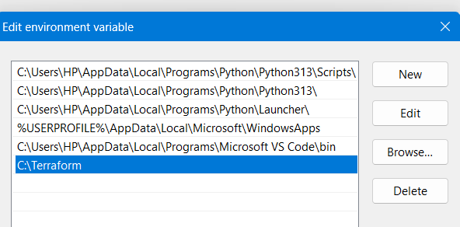

Once you are done with setting the environment variable. Check if terraform is installed using terraform –version command

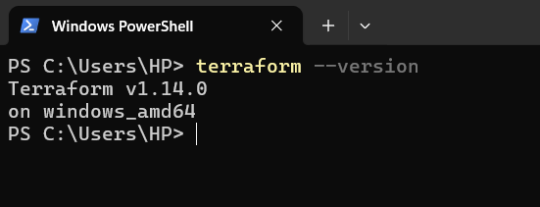

How to install Terraform on Linux (Ubuntu/Debian)

- go to the link https://developer.hashicorp.com/terraform/install
- sudo apt-get update
- wget -O - https://apt.releases.hashicorp.com/gpg | sudo gpg --dearmor -o /usr/share/keyrings/hashicorp-archive-keyring.gpg
- echo "deb [arch=$(dpkg --print-architecture) signed-by=/usr/share/keyrings/hashicorp-archive-keyring.gpg] https://apt.releases.hashicorp.com $(grep -oP '(?<=UBUNTU_CODENAME=).*' /etc/os-release || lsb_release -cs) main" | sudo tee /etc/apt/sources.list.d/hashicorp.list
- sudo apt update
- sudo apt install terraform
- Terraform –version

